Experience

Loss control consultant/owner,

allsource properties llc, laingsburg MIchigan

March 2019-present
Inspects and conducts insurance-risk assessment reports on commercial and high value properties. Specializing in property, general liability and workers compensation. Other responsibilities include; phone interviews, scheduling, organizes & oversees daily operations of office.

Real estate broker/owner

property central realty llc , Evart michigan

april 2007-novemer 2018
Broker/Owner-Real Estate Sales, Residential & Commercial property management, REO management, bank valuations, property preservation services and supervision of 6 real estate agents. Implemented Sales/office procedures/operations, real estate closings, marketing, payroll and hiring of administrative staff.
OFFICE MANAGER/PROPERTY MANAGER
GATEWAY TO HOMES, LANSING MICHIGAN
MARCH 2005-2007
Supervision of administrative staff, organizing office operations/procedures, preparing/submitting payroll, accounts receivable/payables, reviewing sales contracts, conducted monthly office meetings, management of all rental properties, turn-overs, repairs/maintenance , lease signings and hiring of office staff.

EDUCATION
HOLLAWAYS REAL ESTATE INSTITUTE – REAL ESTATE SALES LICENSE
DECEMBER 2000
REAL ESTATE SALES, REAL ESTATE LAW, APPRAISAL ONE, BROKER PREP
jANUARY 2007 – REAL ESTATE BROKER LICENSE

lANSING COMMUNITY COLLEGE- lansing michigan

mICROCOMPUTER SUPPORT SPECIALIST

SEPTEMBER 1999-MARCH 2000

LANSNG EASTERN HIGH SCHOOL , LANSING MICHIGAN.
DIPLOMA 1991

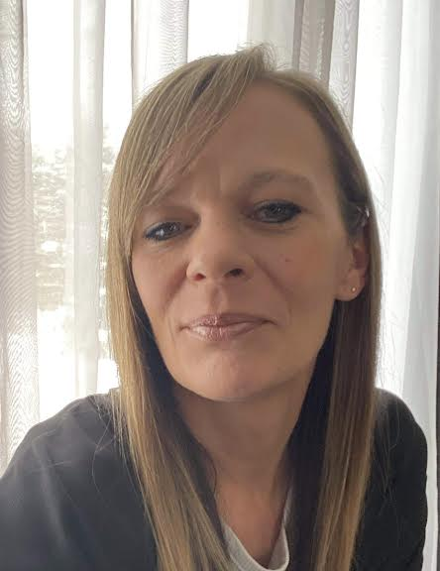

Melanie Tejkl

Real Estate Broker

LOSS CONTROL INSPECTOR

PROFILE
Real Estate Broker with over 23 years of experience in Real Estate Sales, Inspection services and Property management. I possess strong multi-tasking skills, with the ability to simultaneously manage several projects and schedules. Proficient computer/typing skills, attention to details and communicate effectively when working with clients, customers, vendors and service providers. We are a team of 2 loss control consultants. We provide professional loss control reports and property valuations for various insurance companies and financial institutions. Our service area covers All of Michigan, Indiana, Ohio & East Tennessee. With over 23 years as a Real Estate Broker & Property Manager, I have extensive construction/building knowledge, I can effectively assess property damages and liability risk. We also have 20 years of property preservation experience, working with REO properties. Our turn around time is 24-72 hrs.

CONTACT
allsourceinspections@gmail.com
(989)944-3393
8650 Winegar Rd
Laingsburg Mi 48848

ACTIVITIES AND INTERESTS
Gardening * Hiking * Traveling
Home remodel * Property hunting

